import cv2  
import numpy as np  
import matplotlib.pyplot as plt  
import math  
from PIL import Image

img = cv2.imread('A.png',1)  
img = cv2.cvtColor(img, cv2.COLOR_BGR2RGB)

# Translation

height, width = img.shape[:2]  
  
# Set translation amounts  
tx, ty = 80, 80  
  
# Create a grid of (x, y) coordinates  
y_indices, x_indices = np.indices((height, width))  
  
# Flatten the indices and create homogeneous coordinates  
ones = np.ones_like(x_indices.flatten())  
coords = np.stack([x_indices.flatten(), y_indices.flatten(), ones])  
  
# Create the translation matrix  
translation_matrix = np.array([  
 [1, 0, tx],  
 [0, 1, ty],  
 [0, 0, 1]  
])  
  
# Apply the translation matrix to the coordinates  
translated_coords = translation_matrix @ coords  
translated_x, translated_y = translated_coords[0].astype(int), translated_coords[1].astype(int)  
  
# Create an empty output image with the same dimensions  
translated_image = np.zeros((height, width, 3), dtype=np.uint8)  
  
# Map the original image pixels to the translated image  
mask = (  
 (translated_y >= 0) & (translated_y < height) &  
 (translated_x >= 0) & (translated_x < width)  
)  
translated_image[translated_y[mask], translated_x[mask]] = img[y_indices.flatten()[mask], x_indices.flatten()[mask]]  
  
output_image = Image.fromarray(translated_image)  
plt.figure(figsize=(12, 10))  
plt.subplot(1, 2, 1)  
plt.imshow(img)  
plt.title('Original Image')  
plt.axis('Off')  
plt.subplot(1, 2, 2)  
plt.imshow(output_image)  
plt.title('Translated Image')  
plt.axis('Off')  
plt.show()

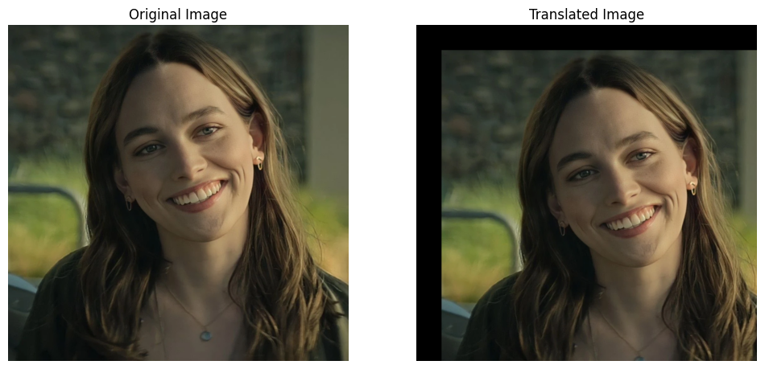

# Rotation

height, width = img.shape[:2]  
  
# Set rotation amount  
rotation_amount_degree = 45  
rotation_amount_rad = np.deg2rad(rotation_amount_degree)  
  
# Calculate the new canvas size to fit the rotated image  
new_height = int(np.ceil(np.sqrt(height**2 + width**2)))  
new_width = new_height  
  
# Create a grid of (x, y) coordinates for the new canvas  
y_indices, x_indices = np.indices((new_height, new_width))  
  
# Calculate the center of the new canvas  
new_center = (new_width // 2, new_height // 2)  
  
# Translate the grid to have the center at (0, 0)  
x_indices_centered = x_indices - new_center[0]  
y_indices_centered = y_indices - new_center[1]  
  
# Create homogeneous coordinates  
ones = np.ones_like(x_indices_centered)  
coords = np.stack([x_indices_centered.flatten(), y_indices_centered.flatten(), ones.flatten()])  
  
# Create the rotation matrix  
cos_a = np.cos(rotation_amount_rad)  
sin_a = np.sin(rotation_amount_rad)  
rotation_matrix = np.array([  
 [cos_a, -sin_a, 0],  
 [sin_a, cos_a, 0],  
 [0, 0, 1]  
])  
  
# Apply the rotation matrix to the coordinates  
rotated_coords = rotation_matrix @ coords  
rotated_x, rotated_y = rotated_coords[0] + width // 2, rotated_coords[1] + height // 2  
  
# Create an empty output image with new dimensions  
rotated_image = np.zeros((new_height, new_width, 3), dtype=np.uint8)  
  
# Map the original image pixels to the rotated image  
mask = (  
 (rotated_y >= 0) & (rotated_y < height) &  
 (rotated_x >= 0) & (rotated_x < width)  
)  
rotated_image[y_indices.flatten()[mask], x_indices.flatten()[mask]] = img[rotated_y[mask].astype(int), rotated_x[mask].astype(int)]  
  
output_image = Image.fromarray(rotated_image)  
plt.figure(figsize=(12, 10))  
plt.subplot(1, 2, 1)  
plt.imshow(img)  
plt.title('Original Image')  
plt.axis('Off')  
plt.subplot(1, 2, 2)  
plt.imshow(output_image)  
plt.title('Rotated Image')  
plt.axis('Off')  
plt.show()

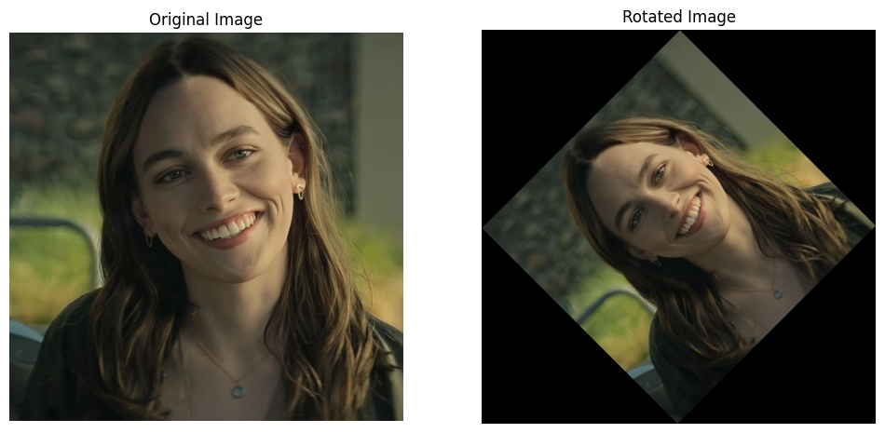

# Scaling

image = cv2.imread("A.png")  
rows, cols, channels = image.shape  
  
scale_x, scale_y = 2.0, 2.0  
  
new_width = int(cols * scale_x)  
new_height = int(rows * scale_y)  
  
x_new = np.linspace(0, cols - 1, new_width)  
y_new = np.linspace(0, rows - 1, new_height)  
  
x_old, y_old = np.meshgrid(np.floor(x_new / scale_x).astype(int),  
 np.floor(y_new / scale_y).astype(int))  
  
x_old = np.clip(x_old, 0, cols - 1)  
y_old = np.clip(y_old, 0, rows - 1)  
  
scaled_image = image[y_old, x_old]  
  
plt.figure(figsize=(12, 10))  
plt.subplot(1, 2, 1)  
plt.imshow(img)  
plt.title('Original Image')  
plt.axis('Off')  
plt.subplot(1, 2, 2)  
plt.imshow(cv2.cvtColor(scaled_image, cv2.COLOR_BGR2RGB))  
plt.title("Scaled Image (2x)")  
plt.axis('Off')  
plt.show()

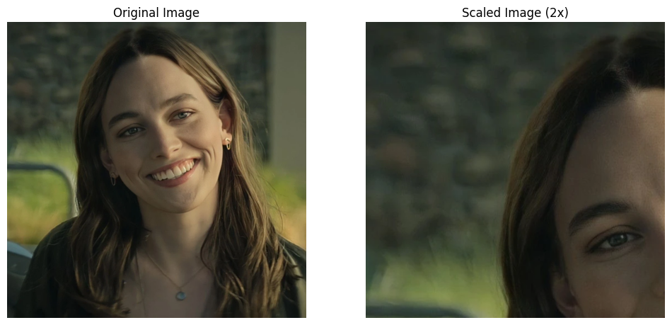

# Shearing

def shear_image(image_path, shear_x=0, shear_y=0):  
 # Open the image using PIL  
 image = Image.open(image_path)  
 original_width, original_height = image.size  
 img_array = np.array(image)  
   
 # Create an empty array for the sheared image  
 new_width = original_width + int(shear_x * original_height)  
 new_height = original_height + int(shear_y * original_width)  
 sheared_image_array = np.zeros((new_height, new_width, img_array.shape[2]), dtype=np.uint8)  
   
 # Loop through every pixel of the new image and map it to the original image  
 for i in range(new_height):  
 for j in range(new_width):  
 # Calculate the original coordinates using the shear matrix transformations  
 orig_x = int(j - shear_x * i)  
 orig_y = int(i - shear_y * j)  
   
 # Ensure the coordinates are within bounds of the original image  
 if 0 <= orig_x < original_width and 0 <= orig_y < original_height:  
 sheared_image_array[i, j] = img_array[orig_y, orig_x]  
   
 # Convert the result array to an image and return it  
 sheared_image = Image.fromarray(sheared_image_array)  
 return sheared_image  
  
sheared_image = shear_image("A.png", shear_x=0.5, shear_y=0.1)   
  
plt.figure(figsize=(12, 10))  
plt.subplot(1, 2, 1)  
plt.imshow(img)  
plt.title('Original Image')  
plt.axis('Off')  
plt.subplot(1, 2, 2)  
plt.imshow(sheared_image)  
plt.title('Sheared Image')  
plt.axis('Off')  
plt.show()

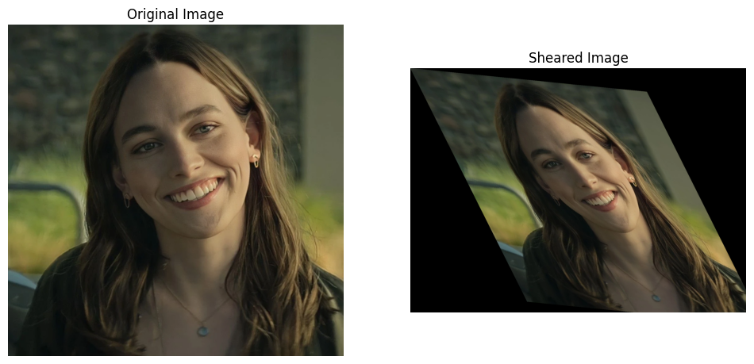

# Reflection

def apply_inversions(image_path):  
 image = Image.open(image_path)  
 img_array = np.array(image)  
   
 # Step 1: Horizontal Inversion (Mirror horizontally)  
 horizontal_inversion = np.flip(img_array, axis=1)  
   
 # Step 2: Vertical Inversion (Mirror vertically)  
 vertical_inversion = np.flip(img_array, axis=0)  
   
 # Step 3: 180-degree Rotation  
 rotated_180 = np.flip(img_array, axis=(0, 1))  
   
 # Step 4: Diagonal Inversion (Reflect across the main diagonal)  
 diagonal_inversion = np.transpose(img_array, axes=(1, 0, 2)) # Transpose the image matrix  
   
 return img_array, horizontal_inversion, vertical_inversion, rotated_180, diagonal_inversion  
  
image_path = "A.png"  
original, horizontal, vertical, rotated_180, diagonal = apply_inversions(image_path)  
  
fig, axes = plt.subplots(1, 5, figsize=(20, 10))  
  
# Display original image  
axes[0].imshow(original)  
axes[0].set_title("Original Image")  
axes[0].axis('off') # Hide axes  
  
# Display horizontal inversion  
axes[1].imshow(horizontal)  
axes[1].set_title("Horizontal Inversion")  
axes[1].axis('off')  
  
# Display vertical inversion  
axes[2].imshow(vertical)  
axes[2].set_title("Vertical Inversion")  
axes[2].axis('off')  
  
# Display 180-degree rotation  
axes[3].imshow(rotated_180)  
axes[3].set_title("180-degree Rotation")  
axes[3].axis('off')  
  
# Display diagonal inversion  
axes[4].imshow(diagonal)  
axes[4].set_title("Diagonal Inversion")  
axes[4].axis('off')  
  
plt.tight_layout()  
plt.show()

